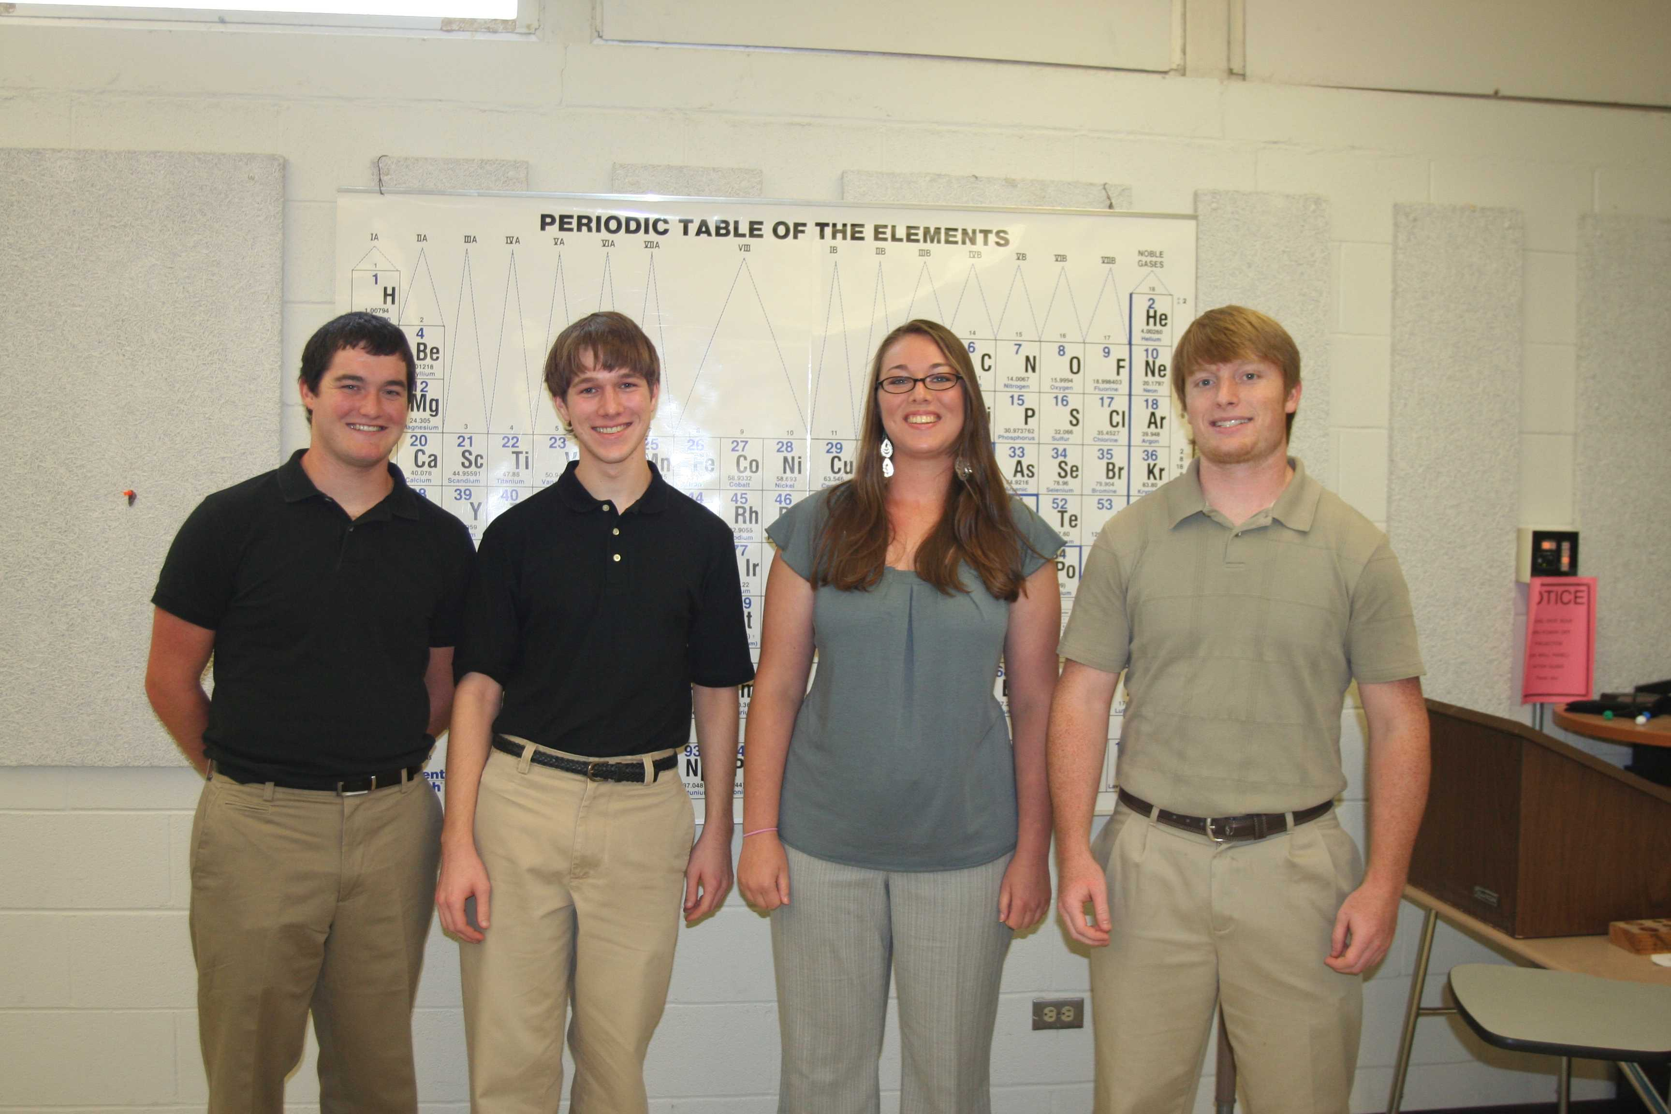Derek Royer, Tim Vinciguerra, Dianna Brown, and Kyle Wilson presented the Chemistry Department Seminar Friday. They discussed their summer research projects. Other students who took part in summer research will be presenting seminars each Friday afternoon for the coming weeks.

News
Andrea Ramirez Fernandez represented Texas this summer at the inaugural “Henry Clay Student Congress: Resolving Conflict in the Contemporary World,” held on the campus of the University of Kentucky in Lexington.

Fifty-one college juniors from every state and the District of Columbia comprised the Inaugural Student Congress. Students were nominated by their respective state’s senior United States Senator and by college and university officials to attend the week-long, masters-level college course in statesmanship.

Fernandez is a political science major with a double minor in criminal justice and philosophy. This summer she completed an internship in the office of Judge Barbara Nellermoe, 45th District Court.

The Student Congress, designed to help educate a new generation in the skills and processes of statesmanship, included a curriculum in diplomacy, dialogue, listening skills, negotiation and mediation.

Athletics
Volleyball – TLU started its 2008 season with a win and a loss Saturday at the Rhodes Invitational, deafeating State University of New York at Brockport and losing to Austin College (Texas). TLU completed a 3-1 run through the Rhodes Invitational with Sunday victories over Piedmont (Ga.) and host Rhodes (Tenn.). The Bulldogs return home to Seguin to prepare for their first home (and American Southwest Conference) match of the season, a 6 p.m. match on Wednesday against Howard Payne in TLU’s Tostengard Activity Center.

Men’s Soccer – TLU opened its 2008 season with a 0-0 tie Friday afternoon at Our Lady of the Lake University. TLU continues the regular season on Sept. 7 with a 3 p.m. home match against non-conference opponent Austin College.

Women’s Soccer - Rhodes College (Tenn.) scored twice in the second half to secure a 2-0 non-conference home win over Texas Lutheran, Saturday morning in Memphis. On Sunday, first-year player Sunny Valencia (Spring/Klein) scored the match-winner four minutes and 49 seconds into the first overtime to lift the Texas Lutheran women’s soccer team to a 2-1 non-conference victory over Birmingham Southern (Ala.).

Miscellaneous
Calling all T-shirt designers!! – The American Southwest Conference is looking for a design that will grace the black T-Shirts worn by all 2008-09 conference champions during post-game celebrations.

Any student currently enrolled at an ASC institution – that means any TLU student – is allowed to submit an entry to the Conference Office by Wednesday, Sept. 24. The winner will receive a $100 honorarium. For more information, click here.

http://www.ascsports.org/News/gen/2008/8/28/ASC_TSHIRTCHALLENGE0809.asp?path=gen

