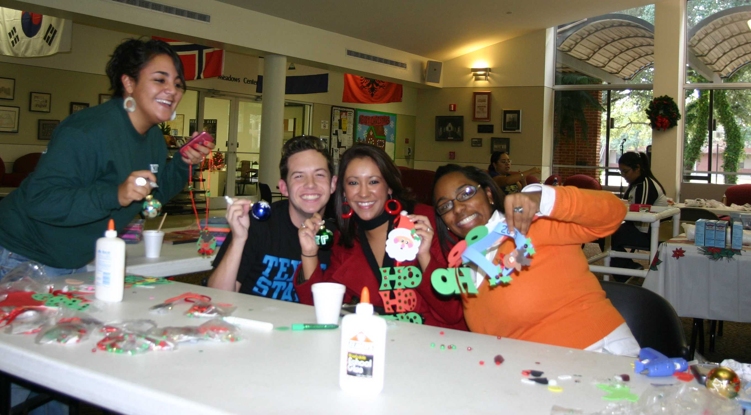
Students Lexie Church, Paul Riser, Stephanie Siller, and Lanika Woodson have fun at the Christmas Bazaar that was hosted by Student Activities and Campus Activities Board.

News
Christmas Vespers will be presented this weekend in Jackson Auditorium. As always, the auditorium will be decorated with beautiful red poinsettias. After Vespers, these poinsettias may be purchased by members of the TLU community for $8 each, which is TLU’s cost. The plants may be picked up Monday, Dec. 4, at Jackson Auditorium from 12:30-1:30 p.m. If you would like to reserve a plant, please e-mail srinn@tlu.edu. You may pay for the plant when you pick it up (checks may be made payable to TLU).

La Posada – MASA and the Moline Center for Servant Leadership will be hosting "Las Posada," a traditional rendition of Joseph and Mary's journey to find a place to stay. The event begins at 6:30 p.m. on Sunday, Dec. 2 at the Chapel of the Abiding Presence and will end in the Center for Servant Leadership building with a piñata, hot chocolate, and Mexican sweet bread. Please join us in celebrating this time honored Mexican tradition.

Fall concerts – Next week the TLU community will have two opportunities to hear TLU concerts. On Sunday, Dec. 2 at 1 p.m. in Ayers Recital Hall, the TLU/Mid Texas Symphony Community Music Academy will present their fall concert of solo and chamber music. A reception will follow.

On Monday, Dec. 3 at 7 p.m. in Ayers Recital Hall the TLU String Ensemble, TLU String Students and the TLU/MTS Community Music Academy Youth Orchestra will present their fall concert of solo, chamber, and chamber orchestra music. The concert will feature Courtney Filner, who is an adjunct professor at TLU, on the Telemann Viola Concerto. A reception will follow. Both performances are free and open to the public.

Hellos and good-byes – Welcome to new employees Lynn Parrott, graphic designer, university relations; and Alejandro Castillo, multi-skilled maintenance technician, facility services.

Sports
Basketball – The TLU men dropped a non-conference game to the University of the Incarnate Word 102-70 last night in San Antonio. TLU received 16 points from sophomore post J.C. Herebia and 13 from junior shooting guard Nate Walton.

The University of Dallas outscored the TLU women’s basketball team by 10 points in the second half to secure a 62-55 non-conference win over the Bulldogs last night. Freshman post Courtney Haskell led the Bulldogs with 17 points and 13 rebounds, and freashman shooting guard Amanda Usselman came off the bench to add 14 points.

Miscellaneous
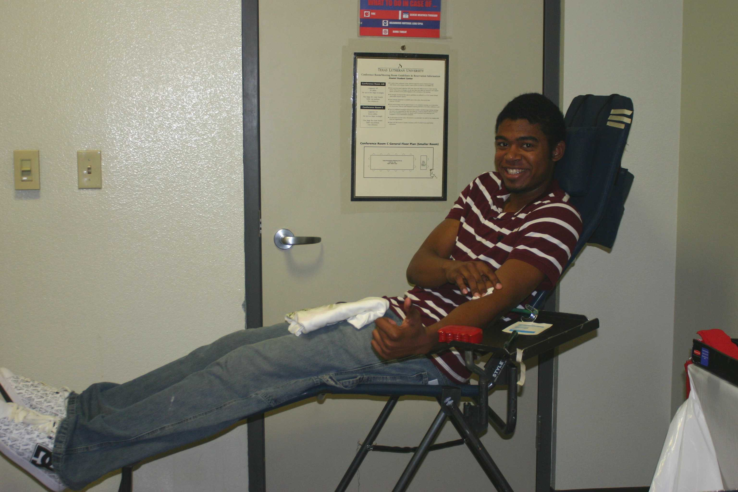
Robert Hatcher was one of the many members of the TLU community who donated blood this week. Thank you to everyone who took part in the blood drive at this critical time of year.

