Student “WPA2” wireless setup
TLU is now requiring the use of “WPA2” (otherwise known as “Wi-Fi Protected Access) security encryption for wireless access to the network. The instructions below are written for Windows Vista, Windows XP with Service Pack 2, and Macintosh OSX. If you have trouble setting this wireless security up, please contact the Help Desk at ishelp@tlu.edu
I. Windows Vista WPA2 setup instructions
II. Windows XP Service Pack 2 WPA2 setup instructions
III. Macintosh OSX WPA2 setup instructions

WPA2 on Windows Vista (student wireless)
- Go to the TLU Intranet page: http://tlu.tlu.edu/is/is_help and download the VistaStudentWifi.zip file to your desktop. Note this file is a script to help automate the installation of the security certificate needed for “WPA2”. It needs to be on the desktop to work correctly.
- Right click the VistaStudentWifi.Zip file and choose “Extract All”
- Right click the file: installStudentWifi and choose “Run as administrator”.
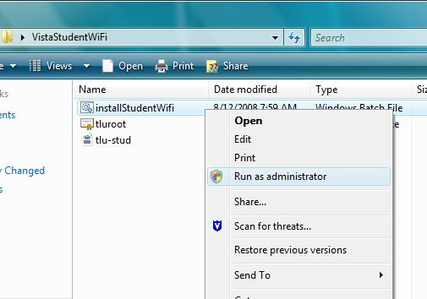

A “DOS” window will appear once the script is initiated. When it finishes, press any key on the keyboard to close the window.
4) In a few moments, a message will appear at the bottom of your screen. Click on the message:
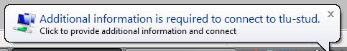

5) At this point the following Login window should appear. Enter your TLU username and password. The logon domain will need to be TLU as shown below. If this windows does not appear or if you have trouble with the process, contact the IT Helpdesk at extension 6000 or via e-mail at ishelp@tlu.edu.
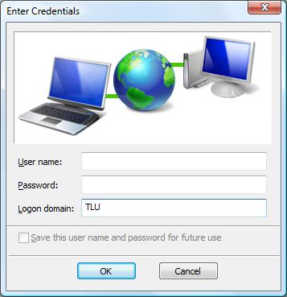

You should now be connected to TLU-Stud, the student wireless network. You may delete the files that were downloaded to your desktop.

WPA2 on Windows XP service pack 2 (student wireless)

1) Using Windows to manage wireless settings. These instructions will only work if Windows is managing the wireless settings. If you have a Dell, Intel, HP or other utility managing your wireless setting they can be setup for WPA2 security but for simplicity sake, this document recommends letting Windows manage the settings. If you see the following screen when you open up your wireless connection then another utility is controlling the settings.
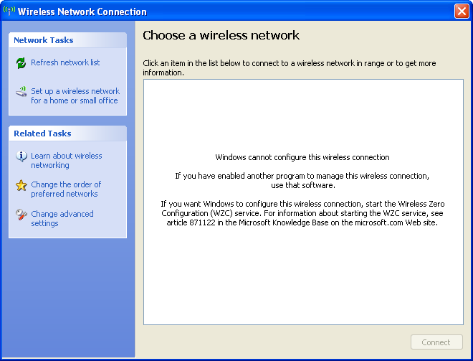

2) Installing the Windows “hotfix”
- Download & install WindowsXP-KB893357-v2-x86-ENU.exe on your computer. This hotfix is located on the TLU Intranet at http://tlu.tlu.edu/is/is_help . The “hotfix” installs support for the WPA2 security services.
- Reboot computer.
3) Installing the “tluroot” certificate. You must install the tluroot certificate prior to following the Enabling “WPA2” wireless security”
- Download the tluroot.cer file from http://tlu.tlu.edu/is_help and save this file to your desktop.
- Double click on the tluroot.cer file that you saved on your desktop.
- Click the “Install Certificate” button.
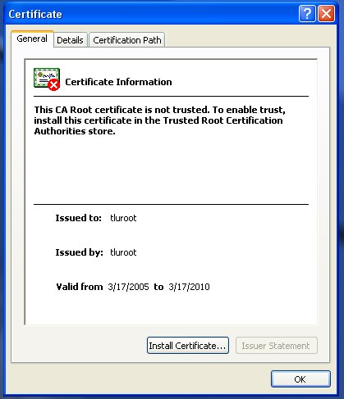
4) Click Next
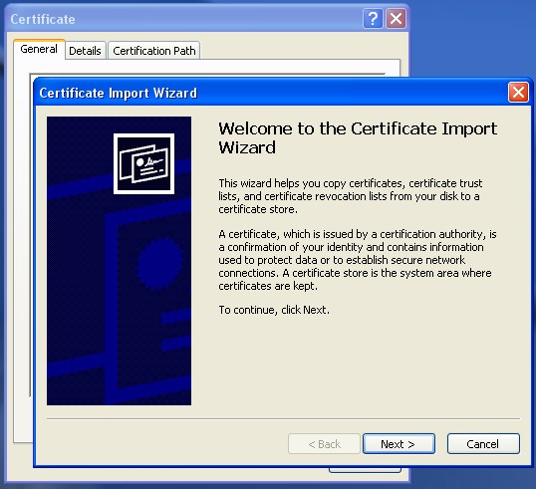

5) Leave the default settings and click next
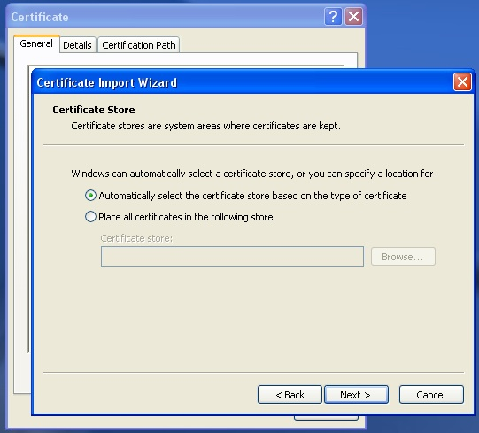
6) Click Finish
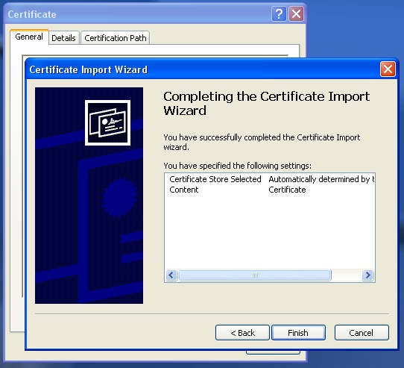
7) Click Yes
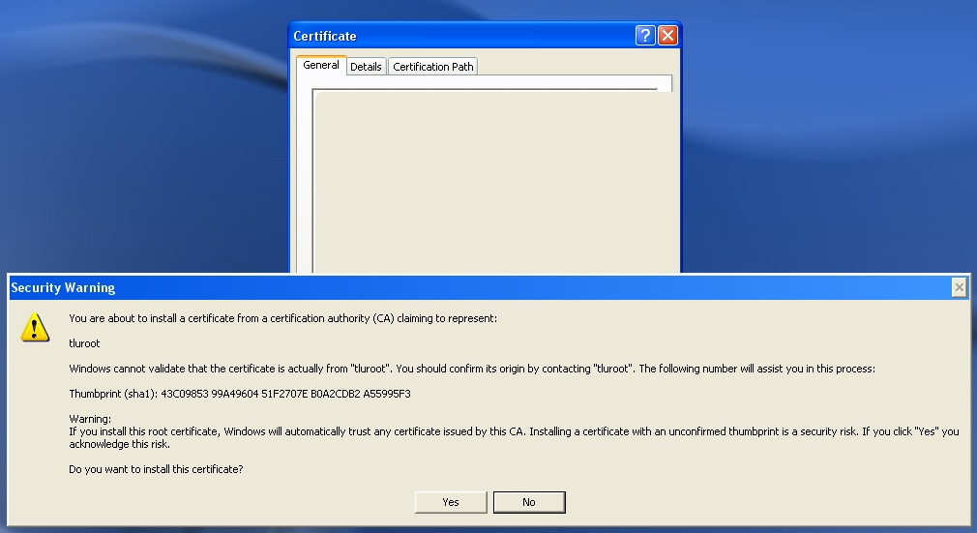
8) Click Ok (twice).
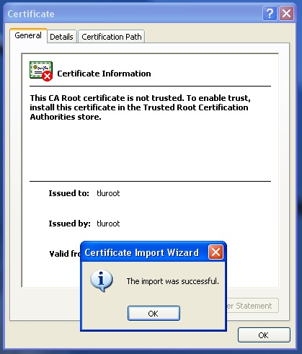

9) Enabling “WPA2” wireless security on Windows XP
- Open Wireless Settings
  - Click START
  - Select CONTROL PANEL
  - Select NETWORK CONNECTIONS
  - Double-click on the wireless network icon
- Add a preferred network called tlu-stud. Make the network authentication “WPA2” and Data Encryption should be AES.
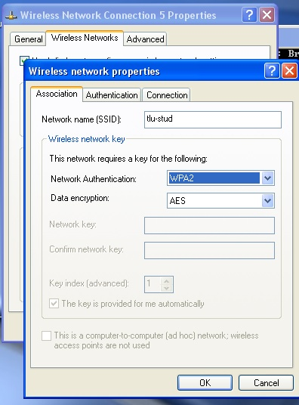

10) Go to the Authentication Tab. Change the “EAP type:” to Protected EAP(PEAP) and uncheck “Authenticate as computer when computer information is available” and also uncheck “Authenticate as guest when user or computer information is unavailable”.
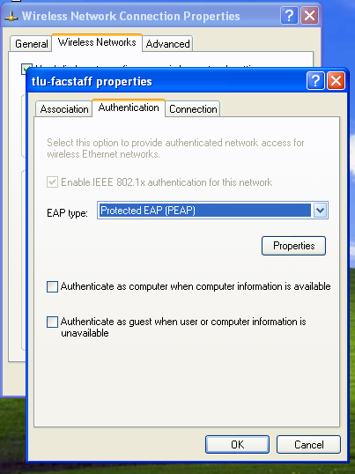
11) Click the “Properties” Button

12) Do the following:
- Check “Validate server certificate”,
- Check “Connect to these servers:”
- Fill in the box with TLUBDC.tlu.edu.
- Check tluroot” (check all of the listings for tluroot ) under “Trusted Root Certificate Authorities”.
- Check “Do not prompt user to authorize new servers or trusted certificate authorities.”
- Choose Secured password (EAP-MSCHAP2 v2) for “Select Authentication Method.
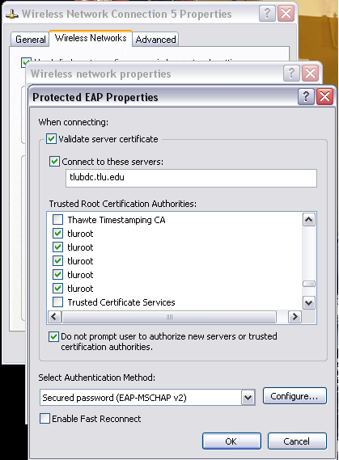

13) Click the “Configure” Button.

14) Make sure “Automatically use my Windows logon name and password (and domain if any), is NOT checked.
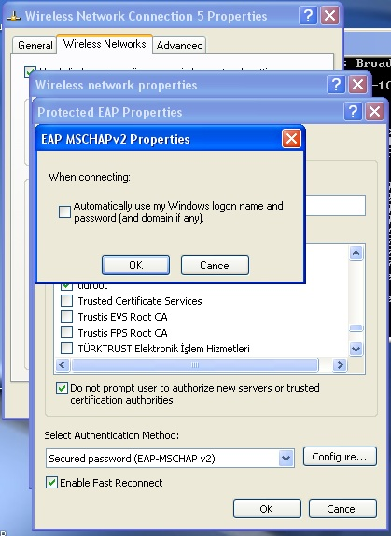

15) Remove tlu-wl from preferred networks if installed.

WPA2 on Macintosh OSX (student wireless)

1) Click the wireless icon (next to the volume control) in the upper right hand corner of your screen.. In the drop-down menu choose “tlu-stud” (student wireless network)
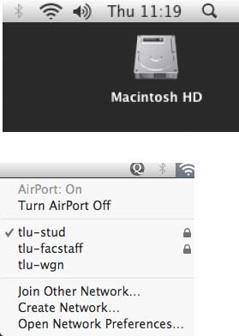

2) Enter you TLU username and password in the login box
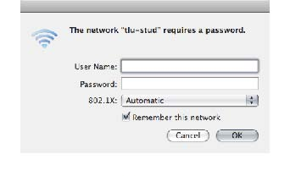
3) Click OK and you should be done!

