Faculty/Staff “WPA2” wireless setup
TLU is now requiring the use of “WPA2” (otherwise known as “Wi-Fi Protected Access) security encryption for wireless access to the network. The instructions below are written for Windows XP with Service Pack 2. If you have a Macintosh, Vista computer, or have trouble setting this wireless security up, please contact the Help Desk at ishelp@tlu.edu
- Using Windows to manage wireless settings on your computer.
- Installing the WPA2 Windows XP hotfix
- Enabling “WPA2” wireless security for your computer
- Other notes

Using Windows to manage wireless settings:
These instructions will only work if Windows is managing the wireless settings. TLU faculty and staff may have Dell or Intel utilities managing wireless settings depending on the hardware. These can be setup for WPA2 security as well but for simplicity sake, this document recommends letting Windows manage the settings. If you see the following screen when you open up your wireless connection then another utility is controlling the settings.
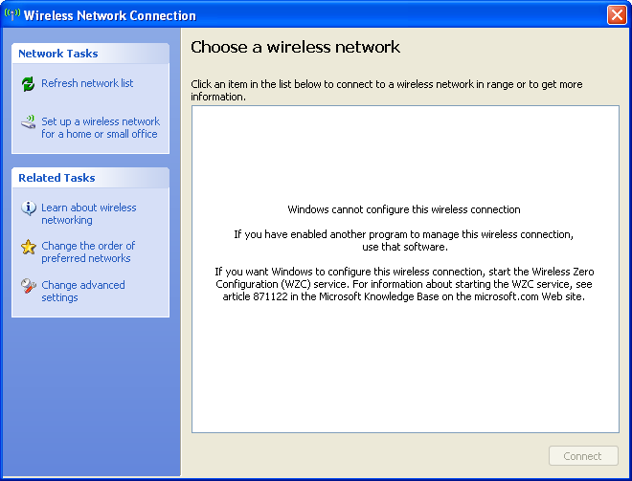

Intel Driver:
If your computer is using the Intel Driver to manage wireless settings you will see a screen similar to this when you open your wireless settings:
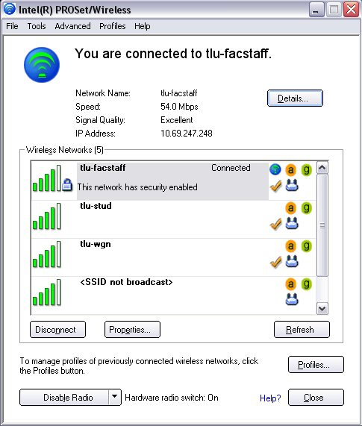
Click on the “Advanced” menu at the top and choose “Use Windows to manage Wi-fi”.

Dell Driver:
If your computer is using the Dell Driver to manage wireless settings you will see a screen similar to this when you open your wireless settings:
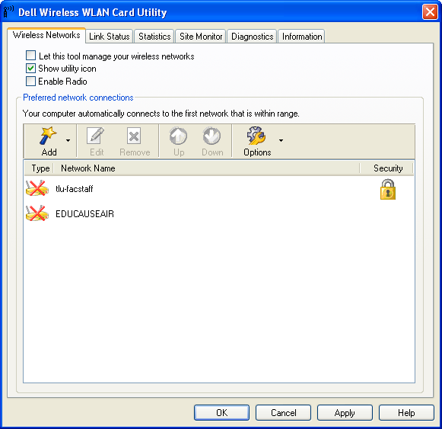
Uncheck the box that says “Let this tool manage your wireless networks”.

Installing the Windows “hotfix”
1) Download & install WindowsXP-KB893357-v2-x86-ENU.exe on your computer. This hotfix is located on the TLU Intranet at http://tlu.tlu.edu/is. The “hotfix” installs support for the WPA2 security services.
2) Reboot computer.

Enabling “WPA2” wireless security
1) Open Wireless Settings
  - Click START
  - Select CONTROL PANEL
  - Select NETWORK CONNECTIONS
  - Double-click on the wireless network icon
2) Add a preferred network called tlu-facstaff. Make the network authentication “WPA2” and Data Encryption should be AES.
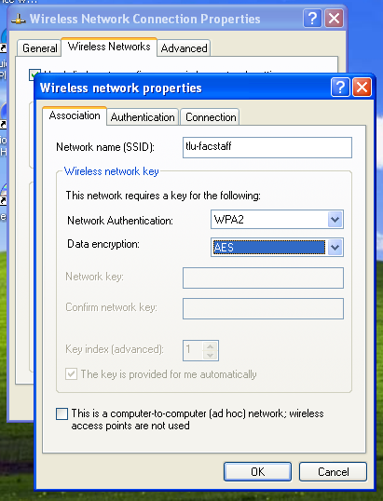
3) Go to the Authentication Tab
4) Change the “EAP type:” to Protected EAP(PEAP) and uncheck “Authenticate as computer when computer information is available” and also uncheck “Authenticate as guest when user or computer information is unavailable”.
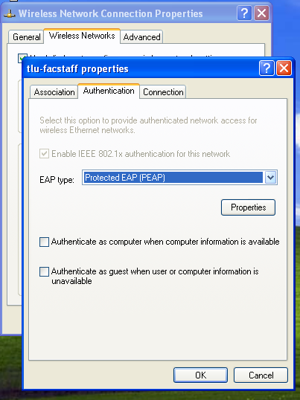
5) Click the “Properties” Button
6) Check “Validate server certificate”, Check “Connect to these servers:” and fill in the box with TLUBDC.tlu.edu. Check “tluroot” (check all of the listings for tluroot ) under “Trusted Root Certificate Authorities”, check “Do not prompt user to authorize new servers or trusted certificate authorities.” Choose Secured password (EAP-MSCHAP2 v2) for “Select Authentication Method.
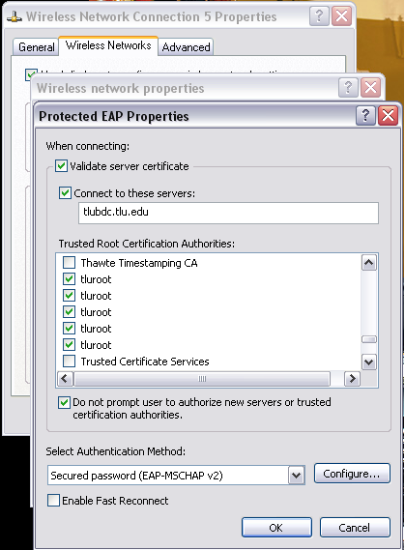

7) Click the “Configure” Button.

8) Make sure “Automatically use my Windows logon name and password (and domain if any), is checked.
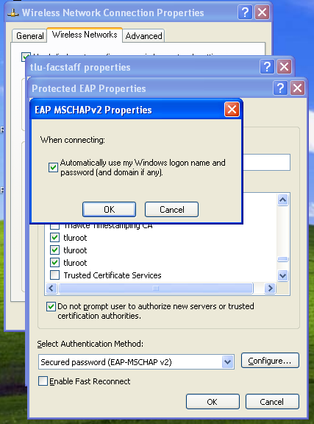

9) Remove TLU-stud, and tlu-wl from preferred networks if installed.

Other Notes:
Login Caching: After the tlu-facstaff wireless network is setup correctly you should enable “login caching”. This will allow you the ability to login to the computer before they have a network connection. To do this, follow these quick steps:
Go to the Information Technology Intranet page http://tlu.tlu.edu/is and double click the entry labeled: “cachedlogon.reg” This utility will set your computer to cache your TLU information so you can login to your computer without the Network. You will need to login to the network once through a hard-wire connection so your credentials are cached for wireless use.
Shared Computers: For laptops that are shared among several users and that use a local login account (not a TLU “Domain” account) uncheck the box in step 8 above. This will prompt the user for a domain login account to access the tlu-facstaff network.

