To adjust Preview Screen select Show/Hide Preview Pane
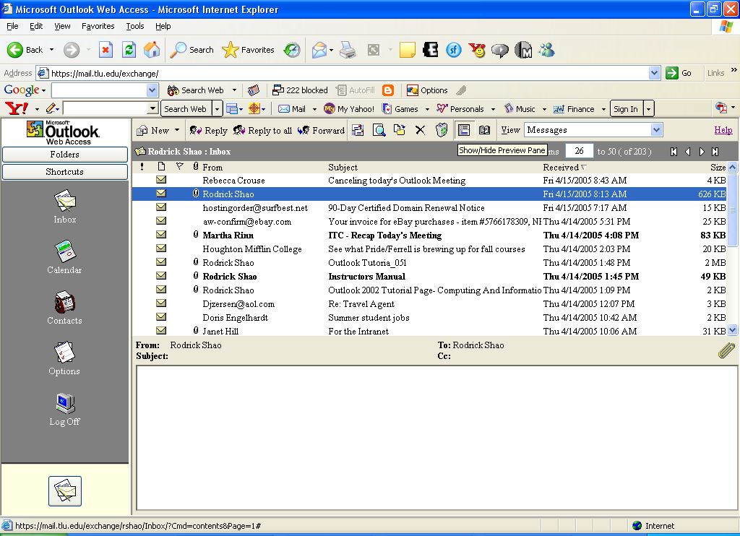
This is a two pane screen.
Step 1

This is a Single pane screen
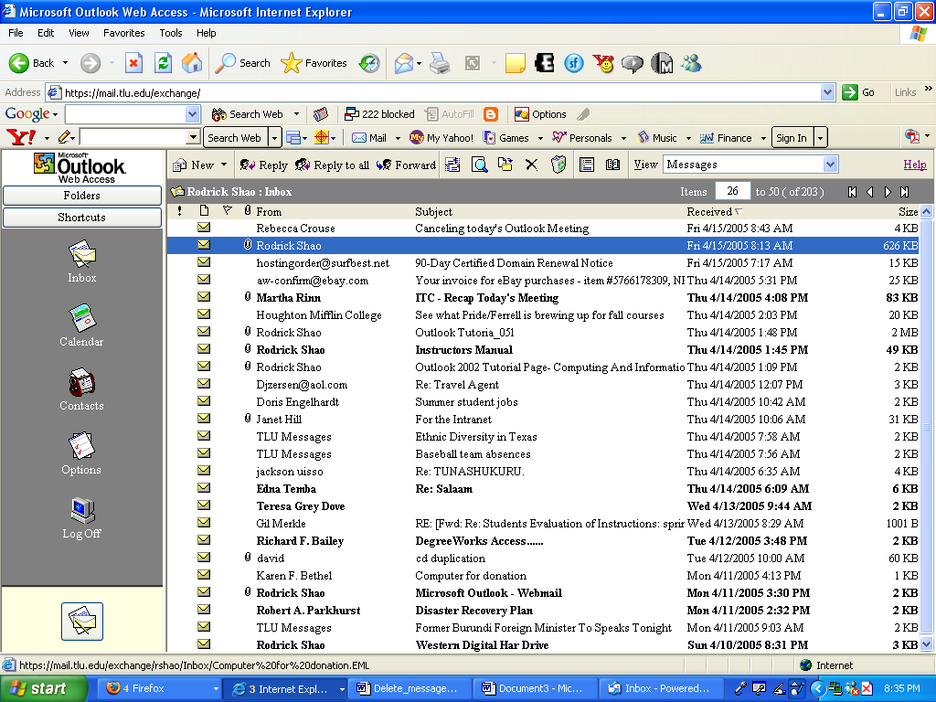
Step 2

