To Access Calendar
Select Calendar Icon
Step 1
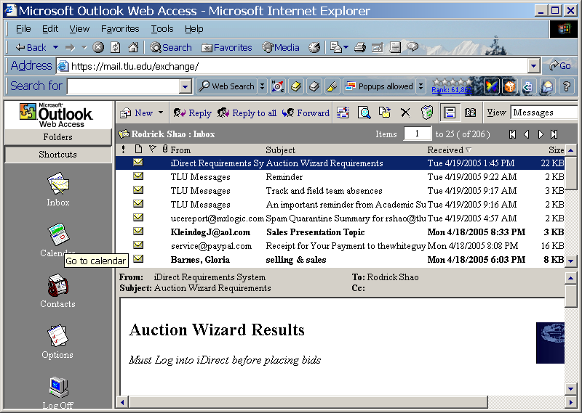

Choose how you want the calendar displayed
Step 2
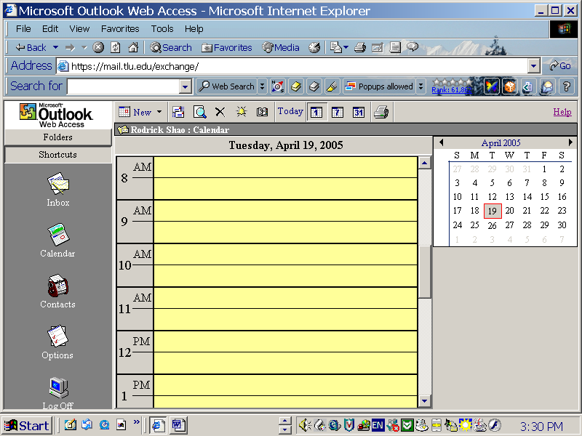
Day, Weekly, & Monthly view.

Select Day of the appointment e.g. April 22, 2005
Step 3
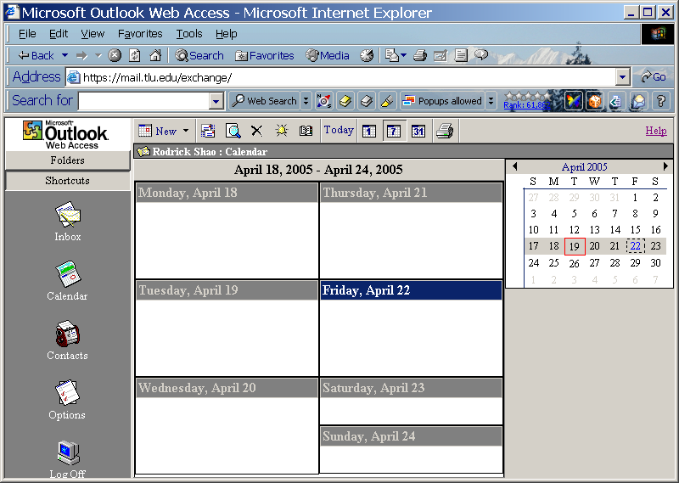

Enter Subject
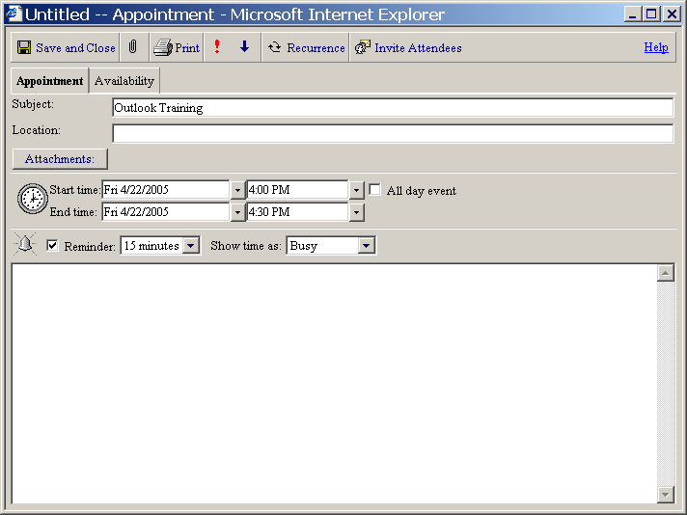
Step 4

Enter Location
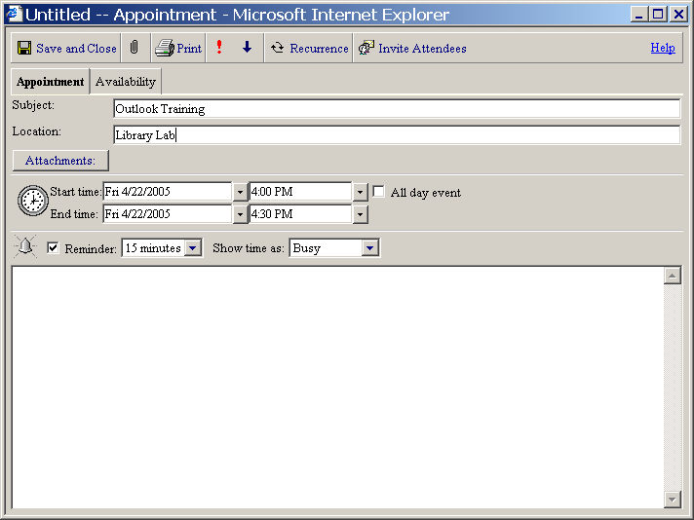
Step 5

Adjust Meeting Time
You can make it an all day event by selecting here.
Step 6
Adjust Time of Reminder
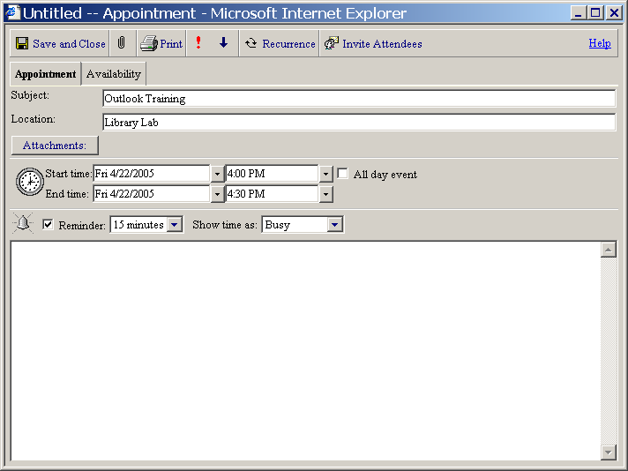
Step 7

Type in any information about the meeting
Step 8
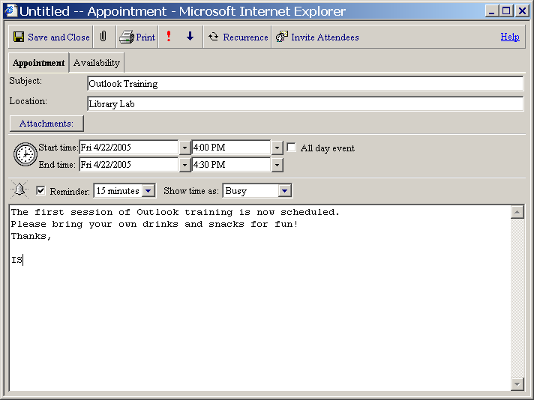
You can Invite Attendees by selecting here
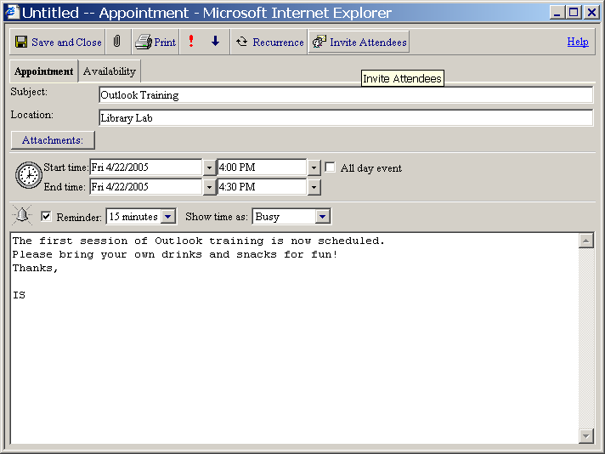
Step 9

Select Required tab
Step 10
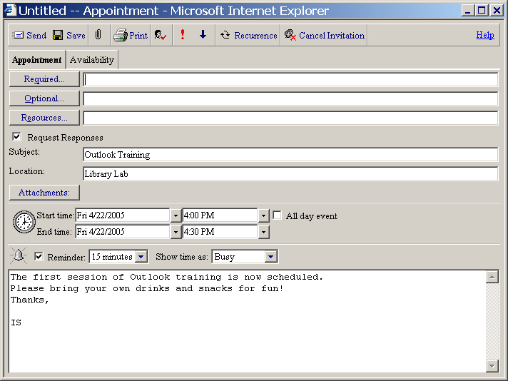
Type in the Last name of intended individual > Click Find
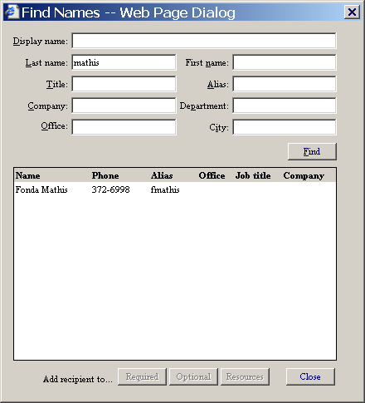
Step 11

Highlight name > Select Required tab to add recipient > Close
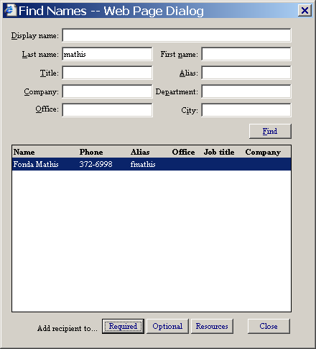
Step 12

Click Save appointment OR Cancel Invitation and Close
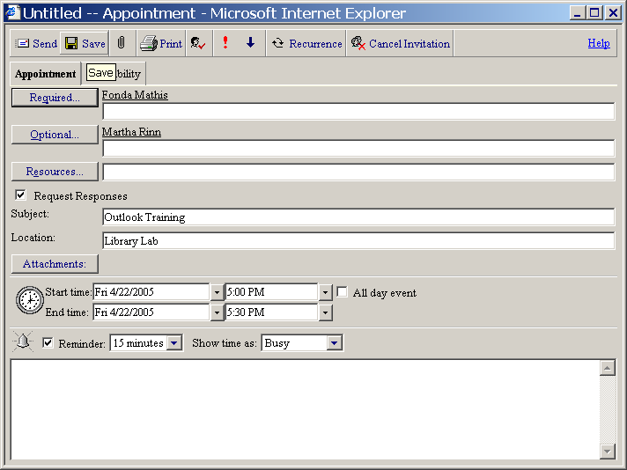
Step 13

Click Send to alert invitees
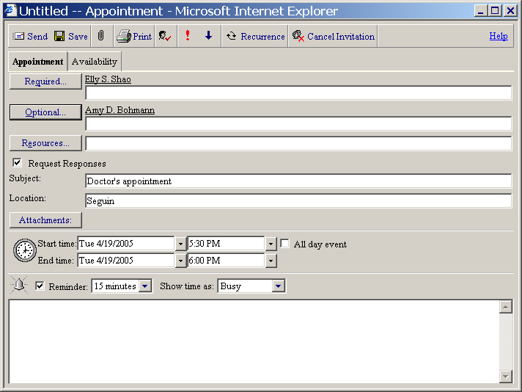
Step 14
See appointment sent from Rodrick’s mail account to a recipient
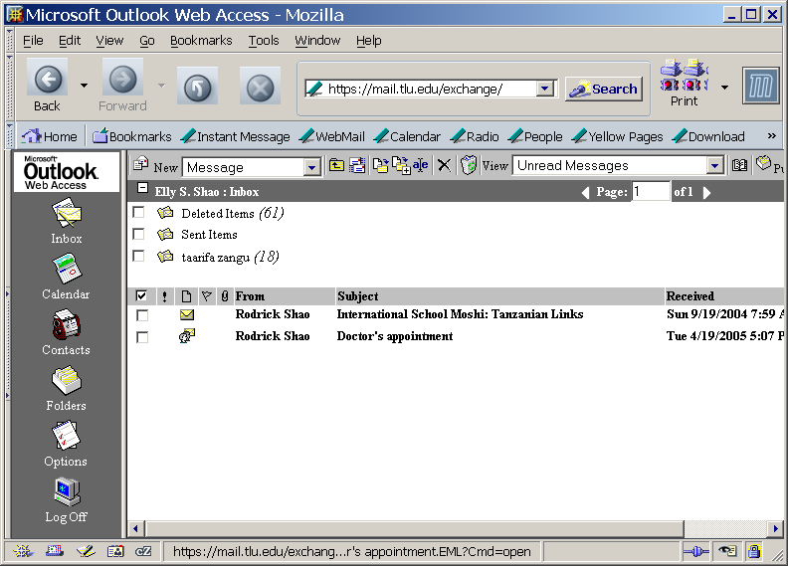
Double click a message to view appointment.
Step 15

Recipient may Accept / Decline invitation here.
Click Accept
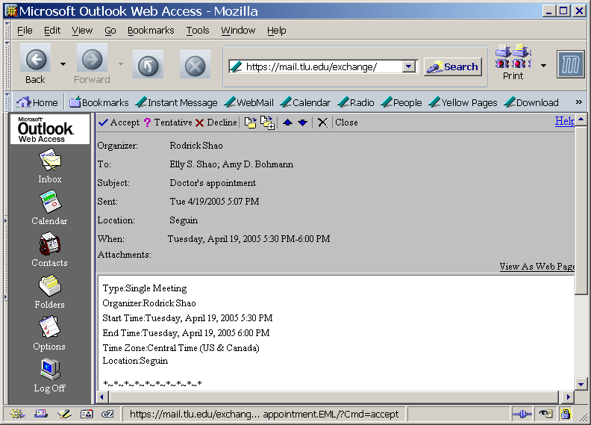
Step 16

As recipient, click Send to accept invitation Or you may Not Send Response
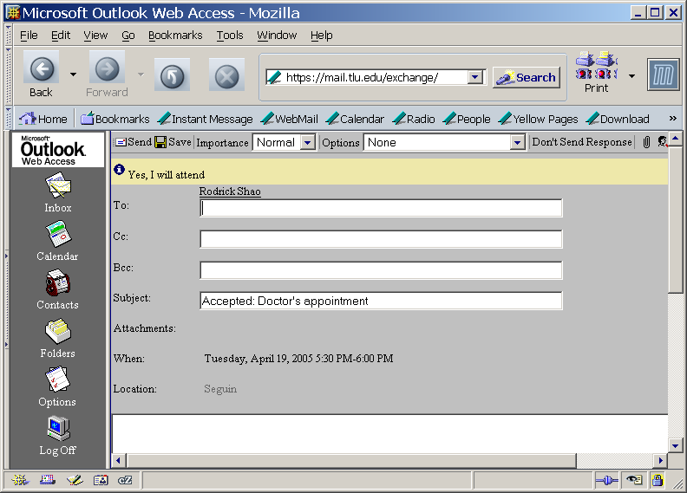
Send to respond.
Step 17

See Recipient’s calendar confirmation.
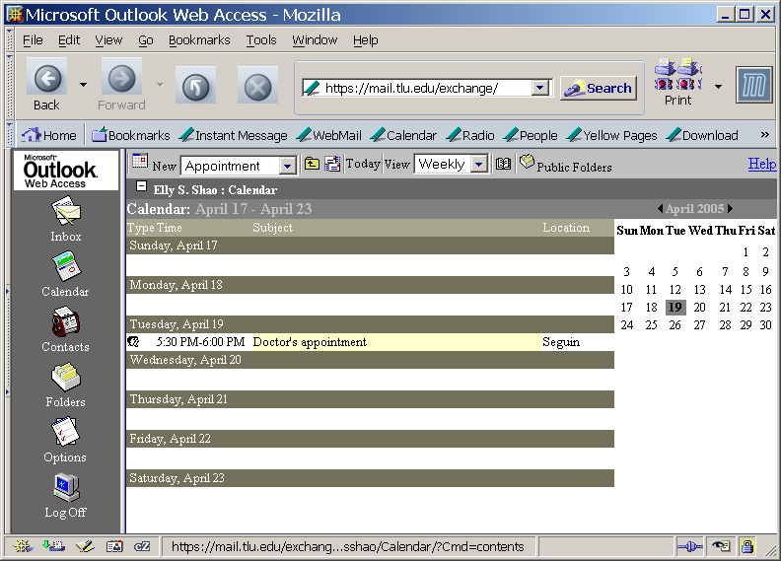
Step 18



